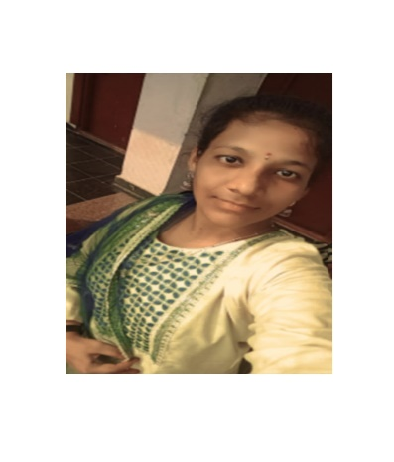

# KATTAMURI SUSMITHA

**Phoneno:8886971984**

**Email**: kattamurisusmitha@gmail.com

**Linked in:** www.linkedin.com/in/kattamuri-susmitha-5692462

­­ **Git**: <https://github.com/susmithallmhttps://github.com/susmithallm>

Veldhurthi, Andhra Pradesh 522613

**Profile** I am Susmitha an engineering student at St. Mary’s group of institutions. I’m motivated by a desire to excel and secure a promising future. With a focus on making the most of my education, I aim to build a solid foundation for a successful career.

# Education

|  |  |  |  |
| --- | --- | --- | --- |
| **Degree** | **Institution** | **Duration** | **CGPA** |
| B.tech(Artificial Intelligence&Data Science) | St. Mary’s group of institutions | October 2022 - Present | 8.2 CGPA |
| Intermediate | St. Joseph Junior College | July 2020 - March 2022 | 86% |
| SSC (Secondary School  Certificate) | Tirumala Oxford, Piduguralla | March 2019 – March 2020 | 10.0 CGPA |

# Skills

* **Java**: Object-oriented programming for application development.
* **Python**: Versatile scripting and development for applications.
* **MERN Stack**: Full-stack web development using MongoDB, Express, React, and Node.
* **SQL**: Database management and structured queries.

# Hobbies

* **Playing carroms**
* **Listening music**
* **Reading news**
* **Watching movies**

# • Involvements and Achievements

* **Scala**

Certificate of Participation.

* **Gate 2025**

Achievement for learning Arithmetic and reasoning.

# Certificates

* Hackathon on Mern stack development-Data valley
* Java full course-Scala
* Introduction to Java - (Learn Quest)
* Introduction to HTML – Data valley
* Introduction to Mern stack development
* Java backend development-Data valley

# Strengths

|  |  |
| --- | --- |
| * Good listener * Team leader * Goal setting * Confident speaker |  |
|  |  |
|  |  |